SCH3U Percent Composition and Mole Quiz CLASS SET

Completion
Complete each statement.

1. The total number of atoms present in 1 mol of gold is ____________________.

2. 6.02 × 10²³ particles of nitrogen gas have a mass of _________________________.

Short Answer
Show your work. Write a sentence stating the correct value for the following questions.

3. Sodium thiosulfate, Na₂S₂O₃, can be used as a fixer in the field of photography. Calculate the percentage composition, by mass, of each element in sodium thiosulfate.

4. A 15.00 g sample of (NH₄)₂SO₄ was analyzed and found to contain 2.28g of nitrogen.
a) Calculate the percent nitrogen in the sample.
b) Calculate the theoretical percentage of nitrogen in (NH₄)₂SO_{4.}

5. Convert 6.27 mol hydrogen peroxide, H₂O₂, into mass (in grams).

6. Determine the number of carbon atoms found in 2.50 mol of methane, CH₄. Explain your answer.

7. Calculate the number of moles of lead present in 8.6 × 10¹⁷ atoms of Pb.

8. Calculate the number of moles found in 168.0 g of iron(II) oxide.

MUST DO THIS: DRAW THIS LINE on your answer page and indicate how confident you feel in this topic and the accuracy of your quiz answers.
**After reviewing the answers & making your corrections, make a second mark on the line in your correction colour.
Not Yet Getting there Got it!!

SCH3U Percent Composition and Mole Quiz /23
Answer Section

BIG NOTE: If any of your answers have different exponents in scientific notation be sure you can get the correct answer on your calculator (eg answer is 3.0 x 10⁻⁶ but your wrong answer is 3.0 x 10⁻³² , you likely have set up the equation properly but not entered the scientific notation properly in your calculator.)

COMPLETION

1. ANS: 6.02 x 10²³

PTS: 1 REF: K/U OBJ: 2.1 STA: CC1.01

2. ANS: 28.0 g

PTS: 1 REF: I OBJ: 2.1 STA: CC1.01

PROBLEM

3. ANS:
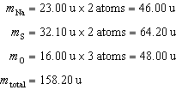

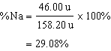

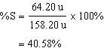

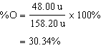
The percentage composition, by mass, of sodium thiosulfate is 29.08% sodium, 40.58% sulfur, and 30.34% oxygen.

PTS: 1 REF: I OBJ: 2.3 STA: CC2.04

4. ANS:
a) 2.28/15.00 * 100 = 15.2%
b) MM = 132.16u, Mn = 28.02u
% = 28.02/132.16*100
= 21.2%

PTS: 1

SHORT ANSWER

5. ANS:
This question uses n= m/MM equation, rearranged to solve for mass below.
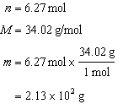
The mass of 6.27 mol hyrogen peroxide is 2.13 × 10² g. (NOTE if you move the decimal point to get out of scientific notation, your answer would be 213 g, SAME number)

PTS: 1 REF: I OBJ: 2.2 STA: CC2.05

6. ANS:
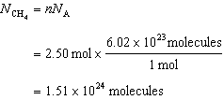
Since there is one carbon atom in each methane molecule, there are 1.51 × 10²⁴ atoms of carbon present.

PTS: 1 REF: I OBJ: 4.4 STA: QC2.03

7. ANS:
This question uses n= N/N_{A} equation.
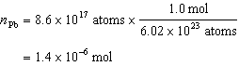

PTS: 1 REF: I OBJ: 4.4 STA: QC2.03

8. ANS:
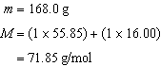

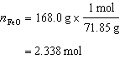
A mass of 168.0 g of iron(II) oxide is equivalent to 2.338 mol.

PTS: 1 REF: I OBJ: 4.4 STA: QC2.03

